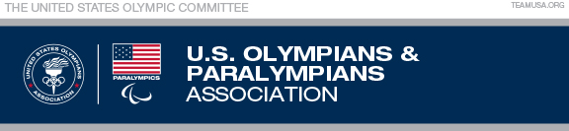
USOPA Conflict of Interest Disclosure Statement
(Approved March 23, 2017)
Please describe the nature of your conflict/potential conflict.
____________________________________________________________________________________________________________________________________________________________________________________
Include the organization/organizations full name/names and your exact title and/or role with each.
____________________________________________________________________________________________________________________________________________________________________________________
Please share with the USOPA Conflict of Interest Sub Committee your thoughts on how to avoid or eliminate any impact on the USOPA.
____________________________________________________________________________________________________________________________________________________________________________________
Signed ______________________________ Date ______________
Print Name ___________________________

