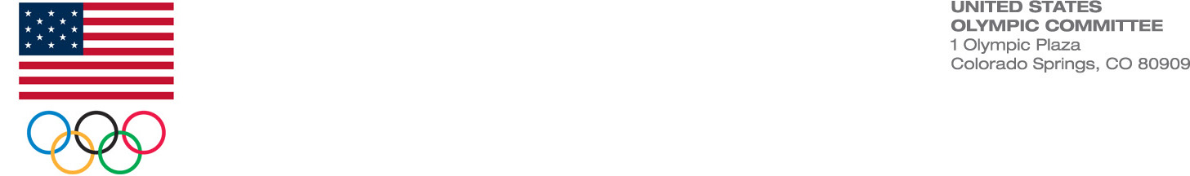 MEMO

To: Matt Van Houten, USA Team Handball
From: Morane Kerek, USOC Audit Division
Date: September 12, 2013
Re: USA Team Handball General Membership Director Election

The Audit Division (Audit) tallied votes for the August 2013 USA Team Handball election of two General Membership Director positions to serve on the USATH Board of Elections. Audit received a total of 85 valid ballots by the deadline of September 6, 2013. Voters ranked the three candidates on the ballot. Each vote was weighted (rank of 1 = 3 points, rank of 2 = 2 points, and rank of 3 = 1 point). The three candidates with the most points are the winners. The results of the election are:

Attila Agoston 175 votes - WINNER
Jennie Choi 176 votes - WINNER
Craig Rot 159 votes

