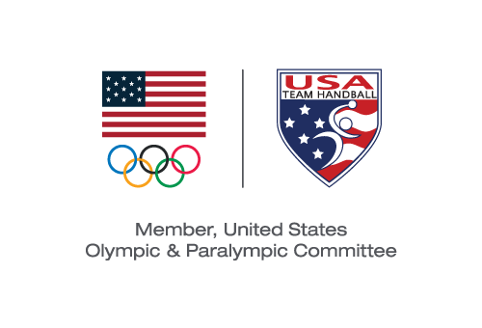
USA TEam Handball BOARD MEETING
Action Taken Without a Meeting Effective November 1, 2019

Pursuant to Section 6.24 of the USA Team Handball (“USATH”) Bylaws, the Board of Directors (the “Board”) took the following actions by email voting with the same effect as action taken at a meeting of the Board:

VOTED: To approve the submission to the United States Olympic & Paralympic Committee of the Athlete Safety Policy presented to the Board.

VOTED: To approve the amendment to Bylaws shown in red below:
“Section 14.7. Administration.
The Judicial Committee shall generally administer and oversee all administrative grievances and right to compete matters filed with USATH. The Judicial Committee shall be responsible to ensure that all complaints are heard in a timely, fair and impartial manner. The Judicial Committee may promulgate procedures in addition to those set forth in these Bylaws for the effective administration of complaints filed with USATH. Individuals appointed to the Judicial Committee will be members who are disinterested persons without conflict of interest to the individuals or situations being heard.”

VOTED: To approve the amendment to the USATH Bylaws shown in red below:

“Section 14.8. Hearing Panel.
Upon the filing of a complaint, the chair of the Judicial Committee, after consultation with the other Committee members, shall appoint a Hearing Panel consisting of three (3) individuals to hear the complaint, at least one (1) of whom must be an athlete who meets the qualifications outlined in Section 12.2 of these Bylaws. The Judicial Committee shall also appoint a Chair of the Hearing Panel. Judicial Committee members may be appointed to and serve on the Hearing Panel. Other individuals who meet the standards of independence as set forth in Section 6.6(B)(ii) of these Bylaws may be identified by the Judicial Committee and may also be appointed to and serve on the Hearing Panel. Members of the panel need not be members of USATH or involved in the sport of Team Handball. All members of any hearing panel shall be disinterested individuals without conflict of interest to the individuals or situations being heard.”

VOTED: To approve the amendment to the USATH Bylaws shown in red below:

8.1.2. Ad Hoc Committees. The Board or the CEO may appoint such Ad Hoc Committees as the Board or CEO believe necessary and appropriate, and shall define narrowly the mission and deliverables of such Task Forces or Committees. Twenty (20) percent of each Ad Hoc Committee appointed pursuant to this Section 8.1.2 must be comprised of individuals who meet the standards set forth in Section 8.8.5 of the USOPC Bylaws, and shall be approved by duly elected Athlete Representatives on the Board. The decision to appoint or not appoint and to terminate such an Ad Hoc Committee, beyond the three (3) Committees described above, shall be exclusively the Board’s or the CEO’s decision.

Michael J. Wall
Chair and President

