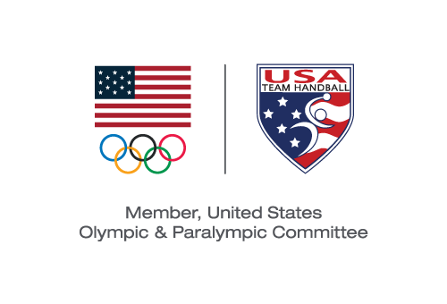
USA TEam Handball BOARD MEETING
Action Taken Without a Meeting Effective July 22, 2019

Pursuant to Section 6.24 of the USA Team Handball (“USATH”) Bylaws, the Board of Directors (the “Board”) took the following action by email voting with the same effect as action taken at a meeting of the Board:

VOTED: To approve the USATH working budget for the period July 1, 2019 through December 31, 2019 and supporting notes presented to the Board.

Michael J. Wall
Chair and President

