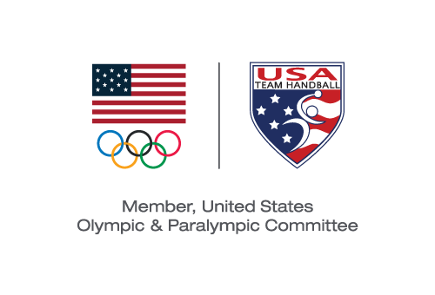
USA TEam Handball BOARD MEETING
Action Taken Without a Meeting Effective February 21, 2020

Pursuant to Section 6.24 of the USA Team Handball (“USATH”) Bylaws, the Board of Directors (the “Board”) took the following actions by email voting with the same effect as action taken at a meeting of the Board:

VOTED: To approve the posting to the USATH website of the following minutes of meetings of the Board held on the following dates:

June 28, 2018
September 9, 2018
October 26, 2018
November 21, 2018
January 16, 2019
April 26, 2019

Michael J. Wall
Chair and President

