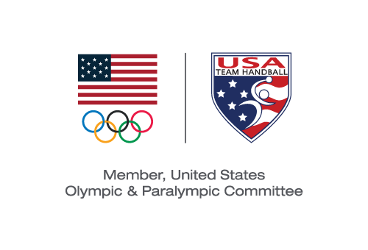
USA TEam Handball BOARD MEETING
Action Taken Without a Meeting Effective August 15, 2019

Pursuant to Section 6.24 of the USA Team Handball (“USATH”) Bylaws, the Board of Directors (the “Board”) took the following action by email voting with the same effect as action taken at a meeting of the Board:

VOTED: To approve the submission to the United States Olympic & Paralympic Committee of the USATH High Performance Plan 2020-2021 presented to the Board.

Michael J. Wall
Chair and President

