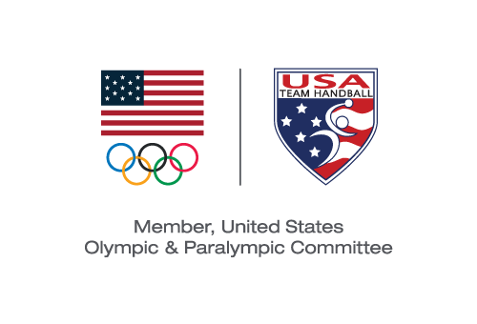
USA TEam Handball BOARD MEETING
Minutes of the July 11, 2019 Board Special Meeting Teleconference
Board Members Present:
Bob Djokovich – Co-Chair
Dee Miller—Co-Chair
David Buckman
Patrick Jalabert
Camille Nichols
JD Orr
David Thompson

Board Members Absent:
Randy Dean
Sarah Gascon

USATH Staff Present:
Barry Siff—CEO

Invited Guest:
Michael Wall
Meeting was called to order at 4:00 p.m. MT by co-chairs, Bob Djokovich and Dee Miller. Ms. Miller provided an update on preparations for the Pan Am tournament, specifically focusing upon the background checks and SafeSport compliance status of the MNT and WNT.
CEO Report—Barry Siff
Barry Siff reported that he was working with Ms. Miller, Jan O’Shea and Dave Gascon to ensure that all MNT and WNT athletes have completed the requisite background checks and SafeSport compliance measures to allow for their participation in the Pan Am games. He also described his experience at the IHF Congress and the desire of the IHF to come to the US in September to celebrate the opening of the NORCA headquarters in Colorado Springs in conjunction with a USATH exhibition game. A discussion ensued around the feasibility of hosting an exhibition game in light of funding requirements. Mr. Siff also described his recent meetings with the CEO of Salming and an EVP of Molten to discuss sponsorship and supply opportunities with USATH. He also described his intention to explore engaging Staffan Olsson as a High Performance Sports Director for USATH on an independent contracting basis and his initial discussions with Hans Vestberg, the CEO of Verizon, concerning Verizon’s potential sponsorship of USATH. A discussion followed concerning the desired extent of communications between the CEO and the Board as to potential sponsorship opportunities. Mr. Siff then referenced the need to hire a Digital Marketing Specialist and a Technical Director, in accordance with the USATH Strategic Plan. A Board discussion followed concerning the desired process for the recruitment and hiring of these positions.
Other matters
A Board member asked for an update as the process for adding to the Board a member representative for Beach Handball. Ms. Miller responded that the election process was established and ready to launch, subject to confirmation as to the members qualified to vote for the representative.
Ms. Miller next called the Board’s attention to the Conflict of Interest Policy that had been provided to the Board in advance of the meeting. She described its contents and asked for a motion to approve the policy as presented. Motion: Motion presented (and it was seconded) to approve the adoption of the Conflict of Interest Policy. Approved by voice vote.
Ms. Miller next called the Board’s attention to the Code of Conduct Policy that had been provided to the Board in advance of the meeting. She described its contents and asked for a motion to approve the policy as presented. Motion: Motion presented (and it was seconded) to approve the adoption of the Code of Conduct Policy. Approved by voice vote.

Ms. Miller and Mr. Djokovich then introduced Mr. Wall and explained the process whereby, in accordance with the resolutions adopted by the Board at its April 26, 2019 meeting, the Nominating and Governance Committee had recruited candidates to serve as Chair of the Board for USATH and had, as a result of this process, recommended Mr. Wall to the Board. Ms. Miller and Mr. Djokovich requested a motion to approve Mr. Wall’s appointment as Chair of the Board of USATH.
Motion: Motion presented (and it was seconded) to approve the appointment of Mr. Wall as Chair of the Board. Approved by voice vote.
Mr. Wall thanked the Board for its appointment and expressed his enthusiasm to undertake this role and to work with Mr. Siff and the Board towards growing Team Handball in the United States.
The meeting was adjourned at 5:15 p.m. MT.
Michael J. Wall served as Secretary

