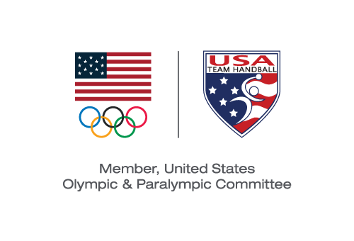
USA TEam Handball BOARD MEETING
Minutes of the August 13, 2019 Board Special Meeting Teleconference
Board Members Present:
Michael Wall -- Chair
David Buckman
Bob Djokovich
Sarah Gascon
Patrick Jalabert
Dee Miller
Camille Nichols
JD Orr
David Thompson

Board Members Absent:
Tracy Deforge

USATH Staff Present:
Barry Siff--CEO
Melissa Zhang—Communications Manager
Meeting was called to order at 4:00 p.m. MT by Chair, Michael Wall. Mr. Wall informed the Board that the new Board member, Tracy Deforge, is enthusiastic about her selection to the Board but regrets being unable to join this meeting.
CEO Report—Barry Siff
Barry Siff started his report by welcoming Melissa Zhang to USATH as its newly-hired Communications Manager, thanked Ms. Miller for her efforts over the last few months in fulfilling various administrative tasks for USATH, and stated that his report would focus upon his draft High Performance Plan for 2020. He noted that last year’s HPP was well-prepared and extensive but USATH was not granted HPP funds. He expressed optimism that the USOPC might provide some funding for 2020. A discussion ensued as to the administrative funding that the USOPC provided to USATH in 2019. Mr. Siff then reported as to each of the following priorities for the 2020-2022 period:

2020-2022 High Performance Plan | Specifics:

- Hiring a High Performance Director (HPD): extremely high priority
Mr. Siff extended an offer to Staffan Olsson to serve in this role on an independent contracting basis for a four-month period through the end of 2019.

- Talent Identification
Mr. Siff said that he will source historic research on talent identification, information provided by the International Handball Federation and talent identification plans written by High Performance Directors for other sports and NGBs. He also described the potential for combining a tryout camp with a media event.

- Athlete Development
Mr. Siff described a training and development process which may involve sending American athletes to Europe to train with a union of 50 top handball clubs in Europe, who are committed to working with American handball players.
The objective is to develop ten male and ten female athletes ages 18-22 who will train for the 2023 and 2027 Pan American Games leading up to Paris 2024 and Los Angeles 2028

- Coaching Development
Mr. Siff noted that USATH currently does little to develop our coaches (national, junior, youth, collegiate, etc.) and there is a need to implement a development process and certification program. This process could include sending prospective coaches to Europe and hosting European coaches in the US for training purposes. A discussion ensued around the need to provide adequate compensation to USATH coaches. A pipeline process is also needed for the development of officials.

- Collegiate Handball
Mr. Siff described the commitment of the IHF to fund collegiate handball programs in the US and noted that, while collegiate programs are an important element of the HPP, USATH would not ask USOPC for related support at this time.

- Competitions in the U.S.
Mr. Siff described the need to present high-level competitions domestically and the desire of NORCA to host the women’s championship in 2021 or in the winter of 2020.

- Beach Handball
Mr. Siff said that, by winning the NORCA championship, USATH Beach Handball has qualified for the IHF world championships in 2020 in Italy and that he doesn’t expect any funding from IHF in upcoming competition.

Mr. Siff noted that the deadline for submitting the HPP to the USOPC is the end of the day on August 15 and that he would work with Mr. Wall and Ms. Miller to finalize the plan by mid-day on August 15. Mr. Wall followed by stating that he would formally request the Board to consent to the submission of the HPP by email on August 15.

Other Updates:

The Board discussed the following topics: Mr. Jalabert offered to assist Mr. Siff in developing a new membership platform. The Board discussed arranging training camps for men’s and women’s teams at the U.S. Olympic & Paralympic Training Center in Colorado Springs. Mr. Wall said that he would reach out to each of the Board members to determine availability and logistics for a Board retreat to be held in Colorado Springs in the next month. Mr. Orr reported that the collegiate working group has met several times at ten-day intervals and has designated subcommittees to address various matters. Mr. Thompson and Ms. Gascon expressed their pride in the performance of the women’s team for making it to the bronze-medal match at the Pan American Games and noted that both national teams performed well in Lima (the men’s team had the most difficult bracket with Argentina, Chile and Cuba) after training for three weeks in Europe.

The meeting was adjourned at 6:55 p.m. MT.

Michael J. Wall served as Secretary

