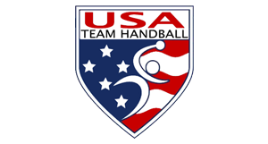
Minutes – Board Teleconference
November 21, 2018
Board Attendees:
Bob Djokovich
Dee Miller
Sarah Gascon
David Thompson
Jennie Choi
David Buckman
Randy Dean
Attila Agoston – In Europe
Mike McNees – absent
Guests: Michael D. Cavanaugh
The meeting started at 6:34 pm CT with roll call, confirmation of meeting being duly called and normal conflict of interest statement made. A quorum was established. It was mentioned that RD and MC were virtually at courtside of the finals of the Men’s IHF Trophy that featured MEX and USA and that conditions did not lend themselves to accurate minutes taking by the normally designated meeting secretary, MC. DM indicated that she would help take notes to go toward the minutes recording after the call.
Compliance Review allows for 90 days to reach resolution with USOC recommendations based upon their audit. DM and MC made the response to the recommendations as required.
Elections: 5 BoD positions coming open – 3 independents and 2 General Membership. N&GC to do a search, N&GC to also seek out from USOC list, also solicit candidates from the general membership by way of notification.
TOO NOISY TO TAKE MINUTES SO NOW MUST RELY ON DM FOR THE REST OF THE MEETING MINUTES

