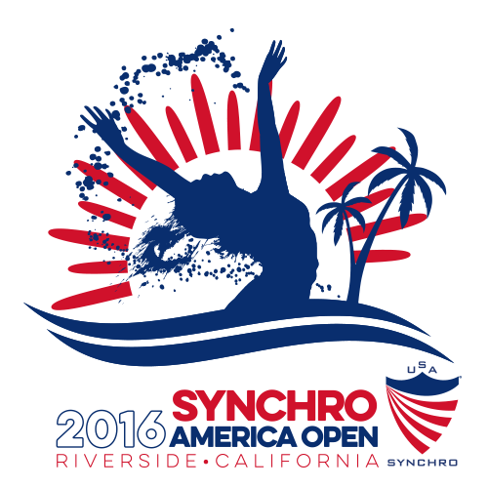
2016 Synchro America Open
U.S. Open Championship Preliminary Entry Form

Estimates for planning purposes only.

Federation/Club Name | Click here to enter text. | 3 letter code | Click here to enter text.
Contact Person Name | Click here to enter text. | Cell phone # | Click here to enter text.
Contact Email Address | Click here to enter text.

Foreign Federations Only
Anticipated Arrival Date/Time | Click here to enter text. | Anticipated Departure Date/Time | Click here to enter text.
Arrival Airport | Click here to enter text. | Departure Airport | Click here to enter text.
Flight Details | Click here to enter text. | Flight Details | Click here to enter text.
Number of hotel rooms needed (rooms have 2 double beds) |  |  | #

Estimated numbers of those attending
Athletes | # | Coaches | # | Officials | # | Support Staff | #

Total estimated numbers of JUNIOR Athletes |  |  | #
Jr. Solos | # | Jr. Duets | # | Jr. Teams | #

Total estimated numbers of SENIOR Athletes |  |  | #
Sr. Tech Solos | # | Sr. Free Solos | # | Sr. Tech Duets | #
Sr. Free Duets | # | Sr. Tech Teams | # | Sr. Free Teams | #

Jr / Sr Free  Combinations | # | Sr. Mixed Tech Duets | # | Sr. Mixed Free Duets | #

Please submit your completed preliminary entry form by May 20, 2016

Foreign Federations and Clubs please send to Betty Hazle: bettyhazle@yahoo.com
U.S. Clubs please send to Janice Sherman: janice@usasynchro.org

For any other questions, please email Meet Manager
Sheila McNabb: smmcnabb@aol.com

