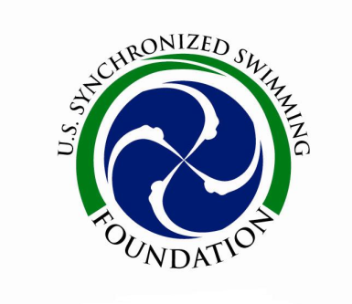
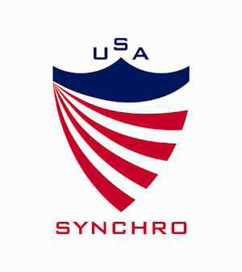

Study Guide for
ASSOCIATION NOVICE/INTERMEDIATE/12-U Age Group
Level 1 Judges Exam 2019

This is an open book test. You will need the following:

- USA Synchro Rulebook (Jan. 2018)
This is found on the Members Only section of the USA Synchro website. You may download it to your personal device or print it out completely.

- FINA Synchronized Swimming Manual for Judges, Coaches and Referees 2017-21
This is in .pdf form on the FINA website:
https://www.fina.org/content/development-publications

- FINA Synchronized Swimming Handbook 2017-21 (FINA Rulebook)
May be downloaded from the FINA.org website using the link below:
https://www.fina.org/content/fina-rules-regulations

Figures – Study & Know:
- General Regulations & Guidelines (USA Synchro Rulebook & FINA Manual)
- Basic Body Positions, (USA Synchro Rulebook & FINA Manual)
- Basic Transitions and Movements (USA Synchro Rulebook & FINA Manual)
- All Novice and Intermediate/12 and Under Age Group Figures (in USA Synchro Rulebook)
- Fundamental Criteria of figure execution (USA Synchro Rulebook & FINA Manual)
- Difficulty in transitions in figures (FINA Manual)
- The differences between Design and Control (USA Synchro Rulebook)
- Understand the NV & PV charts of transitions (FINA Manual)
- FINA Manual Height Chart

**Figure questions will be limited to the Novice. Intermediate and 12-Under Junior Olympic Figures listed for the 2017-2021.
Routines – Study & Know:
- Categories and Percentages for Free Routine and Technical Routine Judging
Execution Execution
Difficulty Impression
Artistic Impression Elements

- Be able to compare difficulty in routines.
Strokes and propulsion techniques
Figures and hybrids
Transitions
Patterns/formations
Risk elements
Synchronization
Placement of difficulty

- Be able to define the Novice and Intermediate Technical Elements.

Miscellaneous
- Appendix G (USA Synchro Rulebook)

