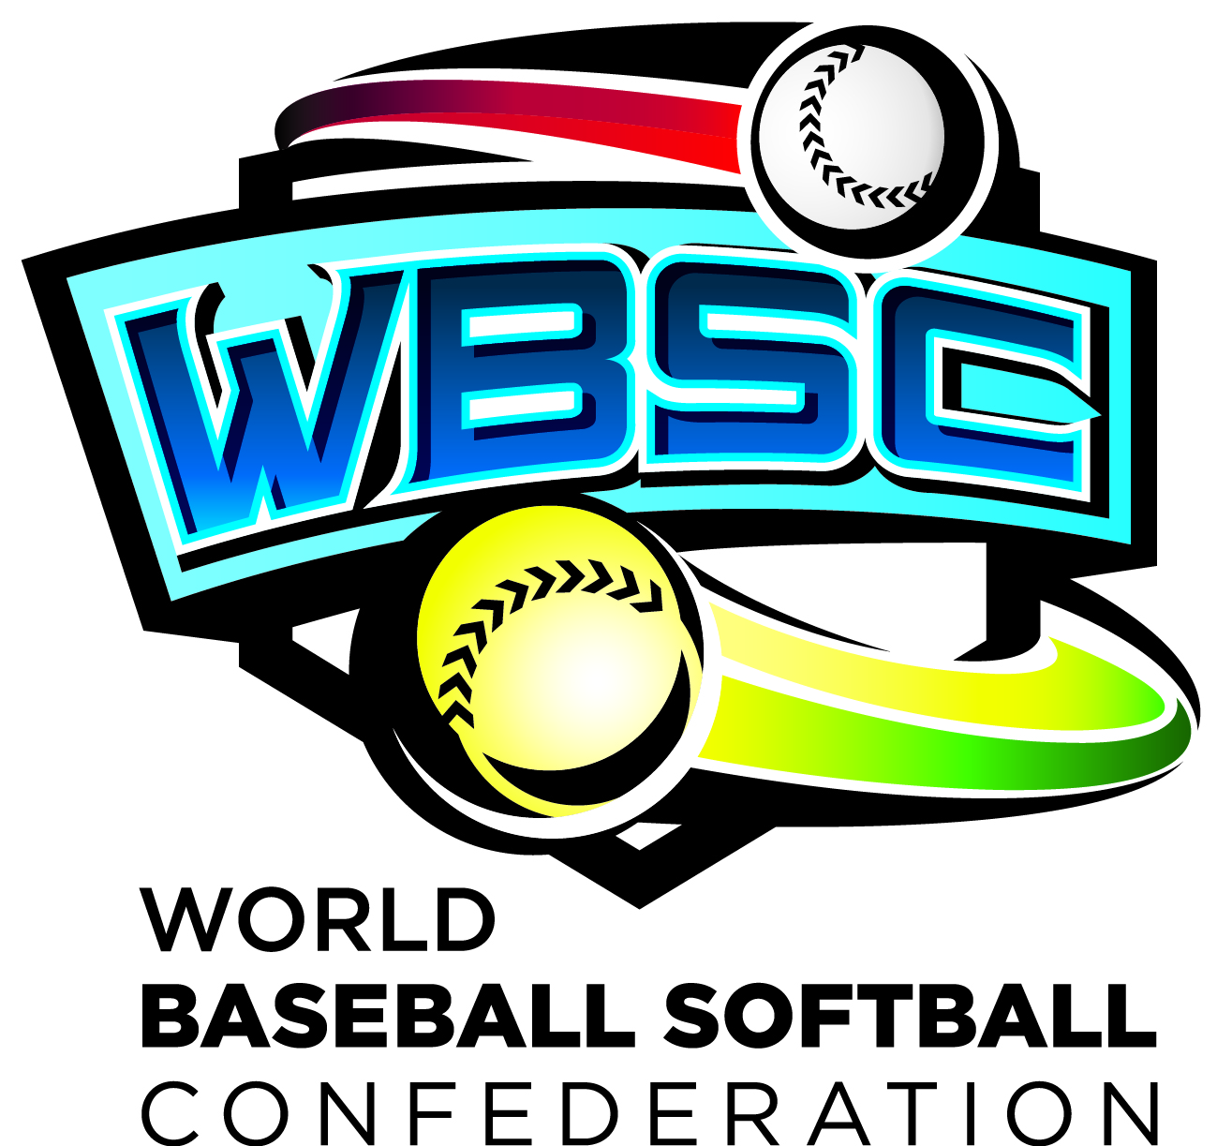
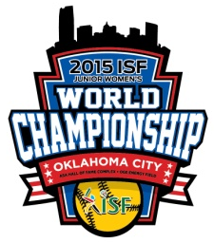
2015 WBSC JUNIOR WOMEN’S WORLD CHAMPIONSHIP
Request for Media Accreditation

(Please type or print; your response in English is appreciated)

AIPS MEMBERS:
Please provide card #/copy

Type of Journalist: WRITER___ PHOTOGRAPHER___ RADIO___ OTHER___

Surname: Given Name: Initial:
Title/Position:
Address:
City: Country: Postal Code:
Work Telephone: Mobile phone:
Fax: E-Mail:

News Organization:
City: Country:
Parent or Associated Media Company (if applicable):
Assignment editor: Phone:
Type of Publication: NEWSPAPER___ MAGAZINE___ TV___ RADIO___ OTHER___
PRINT-Circulation (not readership): _____ WEB-Monthly visits (not hits):_____
Production Schedule: HOURLY___ DAILY___ WEEKLY___ BI-MONTHLY___ MONTHLY___ OTHER___

When do you require accreditation for?
___attending throughout championship August 9-15
___attending only on the following dates (please list):_______________________________________

Does your accreditation require a seat in the press area? Yes___ No___

My photograph is attached for accreditation purposes. Yes___ (Mandatory)

Kindly return your application by no later than July 10, 2015 to:

World Baseball Softball Confederation – Softball Division | 2015 WBSC Junior Women’s World Championship
1900 South Park Road | Plant City, Florida 33563 | USA | Fax: +1 813 864 0105 | Email: info@ISFsoftball.org

