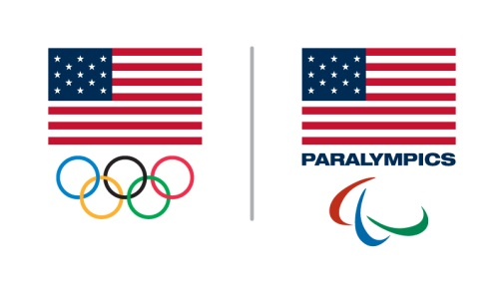
USOC National Team Coach Leadership Education Program
NGB Coach Nomination Form

Coach Nomination Details:
Name: ____________________________________________________________________
Address: ____________________________________________________________________
City: _____________________________ State: ________ Zip: ______________
Phone (home): _____________________ Phone (mobile): ____________________
Email: _______________________________________________________

Position: _________________________________
Sport/discipline: _____________________________________

NGB Details:
NGB Name: ____________________________________________________________________
NGB representative submitting application: ____________________________________________
Position/role: ____________________________________________________________________
Phone (office): __________________ Phone (mobile): ____________________
Email: __________________________________________________________________________

NGB Supporting Statement:
Please outline why the NGB believes the coach should be considered for the program (please use the space below and additional sheets if necessary to fully explain why the USOC should include this coach in the program).

Please outline what steps the NGB will take to support the coach throughout the program (16-18 months), should the coach be accepted:

Application submission:
PLEASE NOTE: ONLY NGBs MAY SUBMIT APPLICATIONS ON BEHALF OF COACHES. NO APPLICATIONS WILL BE ACCEPTED THAT ARE RECEIVED DIRECTLY FROM COACHES. This will ensure that all candidates being considered for this course will have the full support of the NGBs. Coaches should be aware of their nomination by the NGB. This completed application should be accompanied by the coach’s resume and a personal statement from the coach why they should be admitted into the program. The statement should outline why the coach wishes to participate, outlining how this program will impact their coaching performance.

Completed forms must be submitted by January 21, 2019. Please send completed electronic applications to:

United States Olympic Committee
Attn: Christine Bolger, Coaching Education
Christine.Bolger@USOC.org

Applications will be acknowledged within 48 hours of receipt. Please contact Christine with any questions.

Additional notes and guidelines:

When nominating a coach, the NGB (and coach) should consider the following:
- The application should indicate why the USOC should invest in this coach (a $20,000 investment).
- The coach will be employed by the NGB for the duration of the NTCLEP course.
- The coach is currently coaching high performance athletes in a full-time capacity
- The coach has a track record of success in his/her current role of maximizing the potential of the athletes or teams he/she works with.
- The coach demonstrates a history of professional development and an enthusiasm for learning.
- The coach is enthusiastic, open minded, conscientious, self-disciplined and organized.
- The NGB encourages a culture of learning and personal development.
- The USOC acknowledges that it is essential the day-to-day role of the coach is not disrupted. At the same time, the NGB must be willing to support the coach throughout the program, including supporting the coach’s attendance at all NTCLEP course events.
- The NGB can illustrate that the coach’s involvement is likely to have a positive impact on its High Performance Program and High Performance Planning.
- The program is demanding and will test the coach’s commitment throughout the course. Coaches must be fully prepared to take time away from work and family to attend all seminars and distance learning opportunities.

Selection Panel:
All applications submitted by NGBs on behalf of coaches will be reviewed by a panel of high performance and coaching education experts. Consideration will only be given to applications that are received:

- Directly from the NGB on behalf of the coach
- Are complete (no omissions)
- By the deadline

Admission into this program is granted to a select few high performance coaches. Priority will be given to head coaches of elite/national teams. Assistant coaches and “pipeline” coaches may be granted into the program depending on space available and similar level coaches within the cohort.

Interview Process:
Should the selection committee require additional information regarding a coach candidate, an interview may be requested in order to verify that the coach candidate is indeed qualified and committed to enter the program.

Timeline:
Applications will be reviewed that are submitted to Christine Bolger by January 21, 2019. Applicants will be notified by March 1, 2019 and the cohort orientation will begin shortly after with a target of early spring 2018 for the first seminar. The course activities are not intended to interfere with qualifications for or participation in the Olympic or Paralympic Games.

