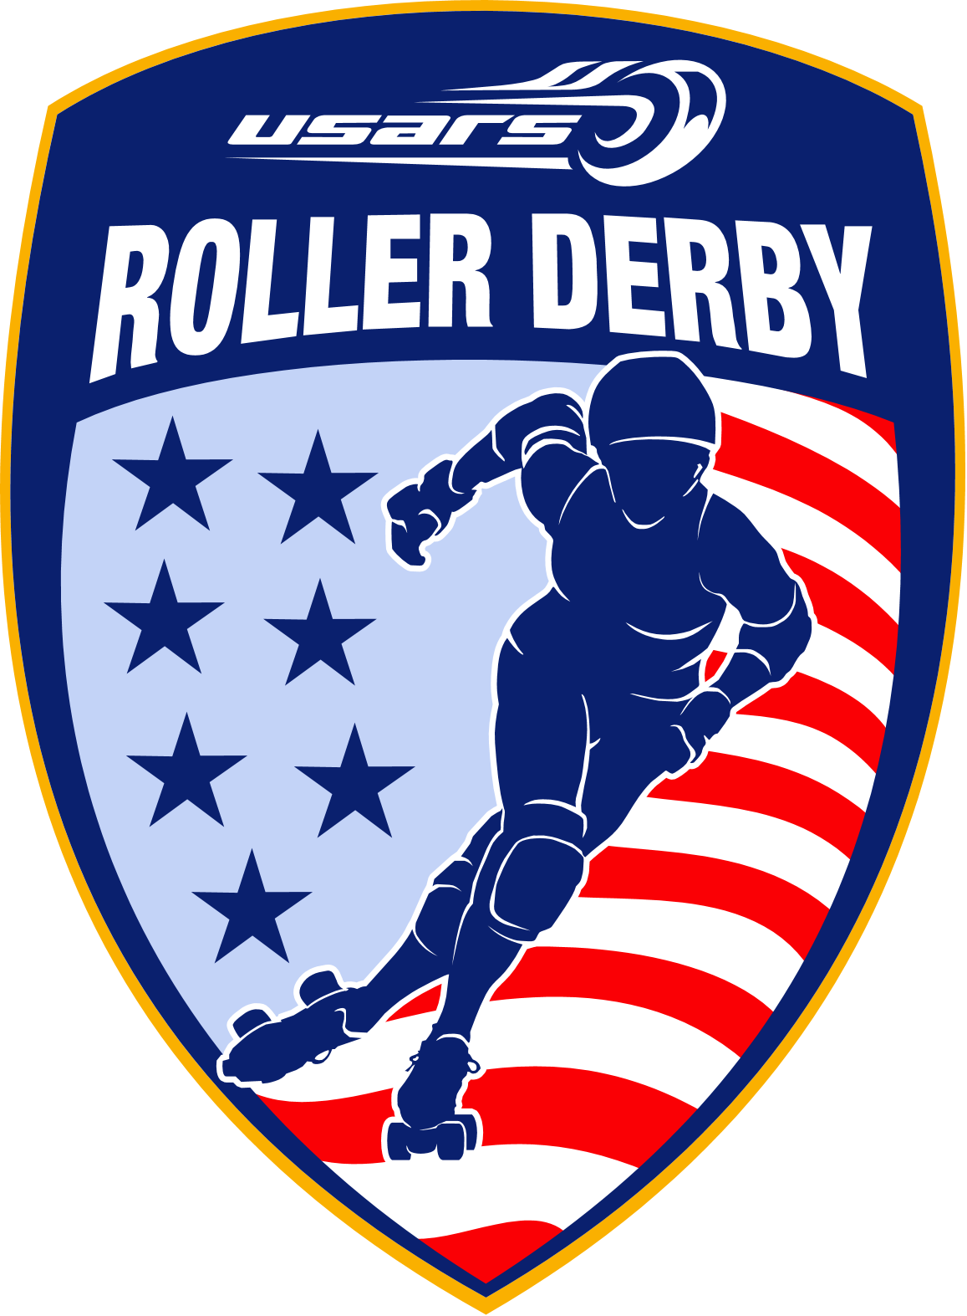
USA Roller Sports Roller Derby Guide 2015
This guide is intended to provide information on how to join USA Roller Sports, as well as the requirements for roller derby member clubs (junior, women’s and men’s). All USARS memberships and club charters are good for the current membership season only.
The 2015 membership season will run from January 1 to December 31, 2015.
Included in this guide, are the steps for properly filling out and submitting the following forms:
- Club Charter Registration and Verification of Officers
- Individual Membership Registration
- Roller Derby Contest Sanction Application
- Roller Derby Contest Insurance Application
All forms are available on the USARS website, www.usarollersports.org (under the Resources tab). Be sure to read all forms thoroughly.
*All applications need to be filled out completely (signatures required) and legibly to ensure timely processing. Incomplete applications will not be processed.

USA Roller Sports is not an insurance company; we are the National Governing Body (NGB) of Roller Sports in the United States and are recognized by the United States Olympic Committee (USOC) as such. We are required by the USOC to carry accident and liability insurance for our clubs, athletes, coaches and officials. USA Roller Sports purchases these policies from an insurance company via an insurance broker.

The insurance policy that USARS purchases for its members is predicated on the following:
- Official practice at a USARS chartered facility or
- A USARS sanctioned competition/event
- Joining in a practice with a WFTDA, MRDA or JRDA team.
- Single skaters or officials participating in a game with a WFTDA, MRDA or JRDA team.
*Events and practices which do not meet the aforementioned will not be covered under the USARS insurance policy.

RENEWING USARS
All club charters and USARS memberships must be renewed each USARS membership season (coordinates with the calendar year, Jan 1-Dec 31). Charters and memberships for 2015 may be purchased any time between September 2014 and December 2015 by submitting a 2015 form. Charters and memberships purchased during this time period will be valid the remainder of 2014, and expire December 31, 2015.
CLUB CHARTERS
The first step in applying for USARS is submitting a club charter application. Once your league finds a facility to practice in, you need to charter the facility. This first charter becomes your “main charter”. The club’s “main charter” becomes the Club ID that is used for memberships and renewals by the USARS National Office. All facilities that are regularly used by a league need to be chartered for insurance to be valid; a separate application is required for each facility. Leagues can charter as many facilities as they would like. A new Club ID is issued for each club charter that is submitted, but the members are only listed under the “main charter”.
A minimum of two club officers and the facility owner/operator must sign off on the club charter application. Charters without these signatures will not be processed. The club officers also need to submit their membership applications with the “main charter”. Remember, all first-time members must include a form of birth verification (copy of driver’s license, birth certificate, passport, etc.) with the membership application. As a club officer, you are able to sign off on all future individual memberships, charters, sanctions, and insurance applications. Clubs with more than one chartered facility can use the same officers for each charter.
The club charter provides the league (and club officers on the charter) with general liability coverage under the USARS umbrella policy. If a member club in good standing is litigated against and coverage applies, the policy will provide defense and pay legal expense. This applies to sanctioned events and practices ON-SKATES only.
If you have a contract with the facility, be sure to include a signed copy of the contract with the club charter. When a contract is involved, USARS requires that the following paragraph be included:
“It is agreed and understood that USA Roller Sports (USARS) shall not be liable for any loss, injury or damage to persons or property arising from circumstances or conditions connected with the facility which are not under USARS’ control or which are not due to the negligence of USARS, or not directly related to USARS’ use of the premises.”
Contracts that fail to include this paragraph risk being denied USARS coverage and/or longer processing time.
Charters will now be classified into two groups:
- Adult (men, women and co-ed may share the same charter)
- Junior
INDIVIDUAL MEMBERSHIPS
Individual memberships can be submitted with the club charter or after the club charter has been processed (not before). USARS excess accident/medical insurance becomes effective when the athlete signs and dates the individual membership application and remits full payment. The USARS National Office must receive the application and payment within 10 days of the dated application for insurance to remain valid. USARS members receive the following benefits:
- Members may participate in USARS sanctioned events.
- A subscription to the USA Roller Sports Magazine for the membership season.
- Insurance coverage under USARS accident insurance policy.
Individual membership applications must be signed by a club officer (as listed on the charter) and the individual. A valid form of birth verification and payment must be included for all new member applications. Applications missing any of the aforementioned will be placed on hold.
The second page of the individual membership application summarizes the accident insurance coverage and USARS benefits. USARS insurance is valid only when participating in an official club practice at a USARS chartered facility or while competing in an official USARS sanctioned competition. Coaches and officials off-skates are also covered during sanctioned events and practices. *Officials may participate in WFTDA, MRDA and JRDA events. Skaters may also participate at the aforementioned events as a single skater. Entire teams wishing to participate must sanction the event.
Non-USARS skaters may skate at a regularly scheduled practice at a chartered facility, but they are not eligible for USARS benefits. It is recommended that the league have these skaters sign a waiver indemnifying and holding harmless USARS, the league, and venue from any and all liability. These skaters must understand that they are solely responsible for the risks that they are taking by participating.
Individual membership applications can take up to 2 weeks to be processed. All current members are listed on the USARS website once processing is complete. For the most current listing of members (updated daily), please check the website: http://usarollersports.org/resources/member-lists.
Roller derby membership fees for 2015 are $65 per adult skater and junior derby membership fees are $40 per skater. Juniors 14 and up that skate on an adult team must pay the adult fee of $65.
SANCTIONS
All games, bouts, tournaments, trainings and other events must be sanctioned by USARS for insurance to be valid. A USARS team participating in a WFTDA, MRDA or JRDA event must also submit a sanction. Sanction applications must be received 30 days prior to the event to avoid late fees ($50) and ensure coverage. Women’s, men’s, and junior roller derby sanctions must be applied for separately.
An “official practice” does not need to be sanctioned. “Official practices” are regularly scheduled (I.e. same days and times- for the most part) practices at a USARS chartered facility where at least one club officer or coach is in attendance. Coaches and officers must be active USARS members. Other USARS league members may participate in another league’s “official practice”. Practices can include drills and scrimmaging.
Something that is advertised (on website, flyers, posters, etc.) is open to the public and is thus considered an “event”. Events must be sanctioned through USARS for insurance to be valid.
If the game/event is taking place in a non-chartered facility or outdoors, you need to submit the aggressive contest insurance application with the sanction application, or provide proof of liability coverage for that facility.
All sanction applications must be signed by an authorized club officer and the facility owner/operator*. Payment for sanction late fees must be submitted with the application. *USARS teams do not need to provide a facility signature when visiting a non-USARS facility.
If there is a contract involved with the facility for the event, your club must include a signed copy of the contract with the sanction application. To ensure that USARS accepts the contract, include the following paragraph in the contract:
“It is agreed and understood that USA Roller Sports (USARS) shall not be liable for any loss, injury or damage to persons or property arising from circumstances or conditions connected with the facility which are not under USARS’ control or which are not due to the negligence of USARS, or not directly related to USARS’ use of the premises.”
The sanction certificate must be displayed during the sanctioned event.
All USARS sanctioned events are listed on the USARS’ website calendar. Page 4 of the sanction application provides a place to list contact information for your event. USARS will display this information on the website once the sanction is approved and processed.
Regular sanction fees for the 2013 season are as follows:
Men, Women and Juniors = No charge ($50 late fee if received after the 30 day deadline)
CERTIFICATES OF LIABILITY INSURANCE
Some facilities require that the event organizers (your league) provide a general liability policy for the facility/venue. If your facility requires this, you must submit the aggressive contest insurance application.
Liability insurance certificates in the amount of $1,000,000 per occurrence with a $5,000,000 general aggregate may be issued naming non-member venues/facilities and meet hosts/sponsors as additional named insured. All conditions for safety of participants must be observed, as noted on the last page of the sanction application. Liability insurance coverage requires that all participants must be USARS members in good standing or hold a single event card.
If your chartered facility(s) requires a certificate of insurance, you can purchase a “blanket certificate”. A “blanket certificate” is good for the entire membership season.
There is usually a contract involved with facilities that require a certificate of insurance. A signed copy of the contract must be included with the insurance application. Insurance applications are not processed until the contract has been reviewed and approved. To speed up this process and ensure that USARS honors the language of the contract, have the facility include the following clause in the contract:
“It is agreed and understood that USA Roller Sports (USARS) shall not be liable for any loss, injury or damage to persons or property arising from circumstances or conditions connected with the facility which are not under USARS’ control or which are not due to the negligence of USARS, or not directly related to USARS’ use of the premises.”
Contracts without this paragraph take longer to review, and risk being denied.
The certificate holder will be listed as what is listed on the specific location of practices/activities (facility name and complete address) line of the insurance application. Please include the entire name and address of the facility on this line as it is to be listed on the insurance certificate. If you are unsure of what needs to be listed refer to the contract or check with the venue.
The completed insurance application must be submitted with the sanction application and a signed copy of the contract (if one exists). Applications received less than 30 days prior to the event may be denied coverage by the insurance company due to short notice.
Certificate of insurance fees for 2015 are as follows:
First five (5) insurance certificates are no charge.
After the five (5) certificates:
Single men, women or junior’s event at chartered or non-chartered facility= $100/day
Blanket certificate for entire season at a men, women or junior’s chartered facility= $200
JUNIOR ROLLER DERBY
To be eligible to be a member of a USARS junior derby league, an individual must be 17 or younger at the beginning of the current membership season (January 1). Individuals that turn 18 over the course of the membership season may finish the season with their league.
For insurance purposes, junior skaters (minors) under the age of 14 cannot be allowed to participate in contact drills or contact skating with adults as this would VOID COVERAGE. This would include participating in USARS sanctioned bouts for adults. However, minors can participate in skating drills that are NON-CONTACT. Any skaters 14 and over that wish to participate in contact drills or play on the adult team must complete the Roller Derby Minor Waiver paperwork.
The club officers on a junior league charter must be at least 18 years of age.
Junior roller derby leagues can not share a charter with a USARS adult league. For insurance purposes, the facility must be chartered for junior derby. A junior league can utilize the same facility as an adult league, but they must hold their own club charter.
All junior roller derby events must be sanctioned (following the same protocol for adult derby events), including events being held as an exhibition or half-time scrimmage during an adult USARS sanctioned event. Regular sanction fees and rules apply to all junior derby events that are being held as a stand alone event or part of a double header.

**Don’t forget to check out the Derby FAQ at http://usarollersports.org/faq/roller-derby-frequently-asked-questions-faq!
USARS Facebook page https://www.facebook.com/UsarsRollerDerby
USARS Roller Derby Teams in the USA Facebook page https://www.facebook.com/groups/USARSrollerderbyteamsinUSA
USARS Roller Derby Rules Facebook page https://www.facebook.com/groups/usarsrules

Please contact the USARS National Office if you have any questions.
USA Roller Sports
4730 South Street
Lincoln, NE 68506
www.usarollersports.org
T: (402) 483-7551 ext. 11 F: (402) 483-1465

