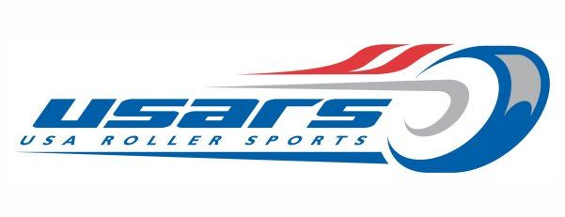

Speed Committee Meeting - July 9th 2020

ATTENDEES
Jay Ingram | Chris Payne
Megan Schuller - Non-voting | Dennis King
Tony Cabral | Kelly Springer - Non voting
Kay Gallatin - Non-voting | Harry Stuart Resigned
Mary Allmond | Gypsy Lucas
Erin Jackson | Ricci Porter-Kmetz - Non-voting
Mckenzie Browne | Brent - Non-Voting

Meeting started at 6:00pm PST
These meeting minutes are automatically approved 3 days from the meeting date unless corrections are requested.

AGENDA

- None presented.. .Free forms with Kelly leading off the discussion topics.

DISCUSSION AREAS
- Pan American “ something “ is still happening. More info to come with Kelly checking with John F.
- Getting feedback that Membership is looking for a Outdoor National Championship
  - Need to verify information but ODN is still on.
- Still having issues with OTC.
  - Late fall before anything happening at COS if at all
  - Possibly need to plan a strictly a road championships
- People are still nervous about the COVID situation
  - People are hearing “why have it” - “how do we protect the athletes” - some places arent even able to open so they cant train.
  - USOC is saying there are troubles with “fair play” in some of their sports.
  - John F would like to see an “event” not necessarily a nat championships
  - Localized events - Invitational events have been strongly suggested to retain membership.
- Membership
  - Hearing that until there are planned events people will not renew memberships
  - August deadline for club charters.
  - Extending memberships? Other orgs have done this.
  - Reach out to committees to see who we can work together in proposing questions.
  - Committee to send in questions to the list so that people can chime in and get a list of questions for the National Office.

COMMITTEE TASK: Each member is encouraged to send to teh committee distro a few questions that will then be aggregated into a master question bank to share to other sport discipline committee chairs as we attempt to gather input from USA RollerSports Members and their thoughts on “Membership” and its value in the next skating season and beyond.
TASK IS DUE 7.10.2020 EOB

OLD BUSINESS
NONE

NEW BUSINESS
NONE
MOTIONS -
NONE

Meeting concluded at 7:10 pm PST
Minutes compiled by Christopher Payne

