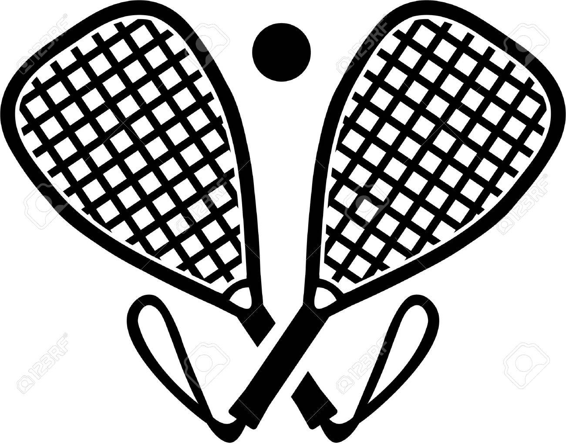
Dear [Facility Owner/Manager]:
Your State Association Logo Here

During these difficult times, it’s obvious that all of us have been negatively impacted. We understand that the fitness industry is not immune to these challenges. In fact, surveys have been conducted that indicate as many as 50% of fitness memberships may either be cancelled or not renewed. This is startling news and a real danger to fitness facilities throughout the country.
However, please know that [State Association Name] joins the racquetball players at your facility - some of your most loyal members - in expressing our appreciation for what you bring to our sport. We truly appreciate the opportunities that your facility offers in providing us with courts.
Facility Owner/Manager Name or Logo Here

Facility Name
4321 First Street
Anytown, State ZIP

8/27/20
1234 Main Street
Anytown, State ZIP

T 123.456.7890
M 123.456.7891

no_reply@example.com
www.example.com
The [State Association Name] looks forward to many more years of partnership with [Facility Name]. If you would appreciate some ideas on court usage or programming, we would be so pleased to help contribute to your future success. Please feel free to reach me at the contact information above to arrange a meeting.
Sincerely,

Your Name Here
Title

[Attach additional board member names/signatures here]

