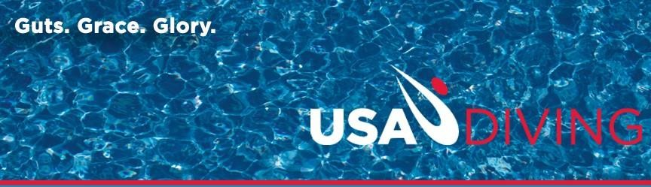

USA Diving Developmental Grant
New Applicants

Local Club Grant Application Title:

Total Amount Requested:

Grant Director Name/Title:

USA Diving Club Name:

Address:

Phone Number:

E-Mail Address:

Please type a separate narrative document and address the questions below. Please be as in depth as possible. You are also required to submit a budget with your application and narrative.
What is your need or problem?

Describe your goals and objectives of this project?

What is your plan for using the Grant? What program(s) do you envision? How will you identify disadvantaged youth for your program?
How will they get to your facility? (Consider partnering with local schools and the Boys and Girls Club

How can this project help your club grow and/or your community?

How will you verify that participants who are benefitting are disadvantaged youth? (Proof must be provided such as authorization for Medicaid, the free/reduced school lunch program, food stamps, Head Start, etc. This is a required element. Participants may be members or non-members.)

Are there other sources of funding for this project? If so, what are those sources?

Grant Director Agreement: I agree to observe the policies of USA Diving and pursue the project as described in this application.

Signature: Date:

Application should be sent to:
Taylor Payne at Taylor.Payne@usadiving.org

